**NAME : P.HIMA SHANKAR**

**ADMISSION NO: 19001F0014**

**SUBJECT : SOFTWARE TESTING METHODOLOGIES**

**GROUP : M.C.A**

**Description:-**

**Food Ordering System Food Ordering System with Source Code is a project that can order some food through digital transaction of ordering. The benefit of the system is to efficiently take the customer order and give them a proper calculation in order to generate a billing receipt. The project was built in a console application, the user can openly access the system without providing a login information. You can navigate the full menu by entering the corresponding keys display in the menu list. The user can take the order of the customer after selecting in the menu, then he/she can give the total price for the ordered item of the customer. The system will auto calculate the ordered item including the quantity of the item and also the available discount. This system can help those who have a catering business or any business that require some automate ordering. When you use this system it can efficiently automate your work and make a faster transaction for customer in no time. The Food Ordering System is a simple project that can make you understand the basic way for coding in python.**

**Food Ordering System using Python with Source Code Features:**

* **(O) Order Menu**
  + **From this menu you can select the customer order item by entering the corresponding numeric keys.**
* **(R) Report Menu**
  + **In this menu you can view all the reports for the daily transcation.**
* **(P) Payment Menu**
  + **For this menu you can receive the payment of the customer for the total ordered item.**

**Program:**

|  |
| --- |
| # Create a list of items  # This file indicates the list of drinks  # Save it as [list_drinks.fsd]  Coca-Cola Rs 5.00  Fanta Rs 5.00  Tea Black Rs 4.00  Sprite Rs 5.00  Airan Rs 8.50  Tea Milk Rs 6.00  Tea Lemon Rs 4.50  Milk Rs 9.00  Water Rs 3.00  Tea Ahmad Rs 5.50  Tea Lipton Rs 5.00  Coffee Black Tea Rs 6.50  Coffee Cappuccino Rs 6.00  Coffee Americano Rs 6.50  Coffee Espresso Rs 6.50  Coffee Latte Rs 5.50  Coffee Mochachino Rs 6.50  Coffee Macchiato Rs 5.00  Coffee Caramel Rs 3.00  Tea Simba Rs 8.50 |

|  |
| --- |
| # Create a list of items  # This file indicates the list of food items  # Save it as [list_foods.fsd]  Chicken BiryanI Rs 35.50  Kadia Chicken Rs 40.20  Mutton Korma Rs 45.80  Dahi Kabab Rs 50.60  Italian Champ Rs 45.50  Veg Noodle Rs 37.30  Masala Chaap Rs 51.80  Egg Curry Rs 35.90  Spring Roll Rs 20.50  Crispy Cord Rs 19.50  Singapoori Noodle Rs 20.40  Beef Bolgogi Rs 80.80  Chili Pork Rs 30.20  Udon Rs 20.60  Grilled halloumi Rs 40.50  Knafeh Rs 32.95  Honey Chicken Rs 30.80  Shanklish Rs 37.40  Shawarma Rs 35.20  Galbitang Rs 20.50 |

|  |
| --- |
| # Create a list of items  # This file indicates the list of food items  # Save it as [list_foods.fsd]  Tent (10x10) Rs 40.00  Chairs (50 units) Rs 10.00  Tables (10 units) Rs 50.00  Table cloths (10) Rs 20.00  Food delivery Rs 10.00  Special music (h) Rs 50.00  Lunch card (30 d) Rs 500.00  Lunch card (10 d) Rs 220.00  Lunch card (7 d) Rs 200.00  Calling taxi Rs 5.00 |

**Code for food ordering system using python 3:**

|  |
| --- |
| print("\n" * 5)  import datetime  import os  list_foods = []  list_drinks = []  list_services = []  list_item_price = [0] * 100  var_discount_1 = 200  var_discount_2 = 1000  var_discount_3 = 5000  var_discount_1_rate = 0.05  var_discount_2_rate = 0.10  var_discount_3_rate = 0.15  navigator_symbol = "/"  if os.name == "nt":  navigator_symbol = "\\"  def def_default():  global list_drinks, list_foods, list_services, list_item_order, list_item_price  list_item_order = [0] * 100  def_default()  def def_main():  while True:  print("*" * 28 + "FOOD ORDERING SYSTEM" + "*" * 24 + "\n")  print("*" * 31 + "MAIN MENU" + "*" * 32 + "\n"  "\t(O) ORDER\n"  "\t(R) REPORT\n"  "\t(P) PAYMENT\n"  "\t(E) EXIT\n" +  "_" * 72)  input_1 = str(input("Please Select Your Operation: ")).upper()  if (len(input_1) == 1):  if (input_1 == 'O'):  print("\n" * 10)  def_order_menu()  break  elif (input_1 == 'R'):  print("\n" * 10)  def_report()  break  elif (input_1 == 'P'):  print("\n" * 10)  def_payment()  break  elif (input_1 == 'E'):  print("*" * 32 + "THANK YOU" + "*" * 31 + "\n")  break  else:  print("\n" * 10 + "ERROR: Invalid Input (" + str(input_1) + "). Try again!")  else:  print("\n" * 10 + "ERROR: Invalid Input (" + str(input_1) + "). Try again!")  def def_order_menu():  while True:  print("*" * 31 + "ORDER PAGE" + "*" * 31 + "\n"  "\t(F) FOODS AND DRINKS\n"  "\t(O) OTHER SERVICES\n"  "\t(M) MAIN MENU\n"  "\t(E) EXIT\n" +  "_" * 72)  input_1 = str(input("Please Select Your Operation: ")).upper()  if len(input_1) == 1:  if (input_1 == 'F'):  print("\n" * 10)  def_food_drink_order()  break  elif (input_1 == 'O'):  print("\n" * 10)  def_other_services()  break  elif (input_1 == 'M'):  print("\n" * 10)  def_main()  break  elif (input_1 == 'E'):  print("*" * 32 + "THANK YOU" + "*" * 31 + "\n")  break  else:  print("\n" * 10 + "ERROR: Invalid Input (" + str(input_1) + "). Try again!")  else:  print("\n" * 10 + "ERROR: Invalid Input (" + str(input_1) + "). Try again!")  def def_full_file_reader():  file_foods = open('files'+navigator_symbol+'list_foods.fsd', 'r')  for i in file_foods:  list_foods.append(str(i.strip()))  file_foods.close()  file_drinks = open('files'+navigator_symbol+'list_drinks.fsd', 'r')  for i in file_drinks:  list_drinks.append(str(i.strip()))  file_drinks.close()  file_services = open('files'+navigator_symbol+'list_services.fsd', 'r')  for i in file_services:  list_services.append(str(i.strip()))  file_services.close()  i = 0  while i <= (len(list_foods) - 1):  if 'Rs' in list_foods[i]:  list_foods[i] = str(list_foods[i][:list_foods[i].index('Rs') - 1]) + ' ' * (20 - (list_foods[i].index('Rs') - 1)) + str(list_foods[i][list_foods[i].index('Rs'):])  i += 1  i = 0  while i <= (len(list_drinks) - 1):  if 'Rs' in list_drinks[i]:  list_drinks[i] = str(list_drinks[i][:list_drinks[i].index('Rs') - 1]) + ' ' * (20 - (list_drinks[i].index('Rs') - 1)) + str(list_drinks[i][list_drinks[i].index('Rs'):])  i += 1  i = 0  while i <= (len(list_services) - 1):  if 'Rs' in list_services[i]:  list_services[i] = str(list_services[i][:list_services[i].index('Rs') - 1]) + ' ' * (20 - (list_services[i].index('Rs') - 1)) + str(list_services[i][list_services[i].index('Rs'):])  i += 1  def_full_file_reader()  def def_file_sorter():  global list_foods, list_drinks, list_services  list_foods = sorted(list_foods)  list_drinks = sorted(list_drinks)  list_services = sorted(list_services)  i = 0  while i < len(list_foods):  list_item_price[i] = float(list_foods[i][int(list_foods[i].index("Rs") + 2):])  i += 1  i = 0  while i < len(list_drinks):  list_item_price[40 + i] = float(list_drinks[i][int(list_drinks[i].index("Rs") + 2):])  i += 1  i = 0  while i < len(list_services):  list_item_price[80 + i] = float(list_services[i][int(list_services[i].index("Rs") + 2):])  i += 1  def_file_sorter()  def def_food_drink_order():  while True:  print("*" * 26 + "ORDER FOODS & DRINKS" + "*" * 26)  print(" |NO| |FOOD NAME| |PRICE| | |NO| |DRINK NAME| |PRICE|")  i = 0  while i < len(list_foods) or i < len(list_drinks):  var_space = 1  if i <= 8:  var_space = 2  if i < len(list_foods):  food = " (" + str(i + 1) + ")" + " " * var_space + str(list_foods[i]) + " | "  else:  food = " " * 36 + "| "  if i < len(list_drinks):  drink = "(" + str(41 + i) + ")" + " " + str(list_drinks[i])  else:  drink = ""  print(food, drink)  i += 1  print("\n (M) MAIN MENU (P) PAYMENT (E) EXIT\n" + "_" * 72)  input_1 = input("Please Select Your Operation: ").upper()  if (input_1 == 'M'):  print("\n" * 10)  def_main()  break  if (input_1 == 'E'):  print("*" * 32 + "THANK YOU" + "*" * 31 + "\n")  break  if (input_1 == 'P'):  print("\n" * 10)  def_payment()  break  try:  int(input_1)  if ((int(input_1) <= len(list_foods) and int(input_1) > 0) or (int(input_1) <= len(list_drinks) + 40 and int(input_1) > 40)):  try:  print("\n" + "_" * 72 + "\n" + str(list_foods[int(input_1) - 1]))  except:  pass  try:  print("\n" + "_" * 72 + "\n" + str(list_drinks[int(input_1) - 41]))  except:  pass  input_2 = input("How Many You Want to Order?: ").upper()  if int(input_2) > 0:  list_item_order[int(input_1) - 1] += int(input_2)  print("\n" * 10)  print("Successfully Ordered!")  def_food_drink_order()  break  else:  print("\n" * 10 + "ERROR: Invalid Input (" + str(input_2) + "). Try again!")  except:  print("\n" * 10 + "ERROR: Invalid Input (" + str(input_1) + "). Try again!")  def def_other_services():  while True:  print("*" * 29 + "OTHER SERVICES" + "*" * 29)  print(" |NO| |SERVICE NAME| |PRICE|")  i = 0  while i < len(list_services):  print(" (" + str(81+ i) + ")" + " " + str(list_services[i]))  i += 1  print("\n (M) MAIN MENU (P) PAYMENT (E) EXIT\n" + "_" * 72)  input_1 = input("Please Select Your Operation: ").upper()  if (input_1 == 'M'):  print("\n" * 10)  def_main()  break  if (input_1 == 'E'):  print("*" * 32 + "THANK YOU" + "*" * 31 + "\n")  break  if (input_1 == 'P'):  print("\n" * 10)  def_payment()  break  try:  int(input_1)  if (int(input_1) > 80) and (int(input_1) < 100):  print("\n" * 10)  print("Successfully Ordered: " + str(list_services[int(input_1) - 81]))  list_item_order[int(input_1) - 1] = 1  def_other_services()  break  else:  print("\n" * 10 + "ERROR: Invalid Input (" + str(input_1) + "). Try again!")  except:  print("\n" * 10 + "ERROR: Invalid Input (" + str(input_1) + "). Try again!")  def def_report():  while True:  print("*" * 33 + "REPORT" + "*" * 33 + "\n")  file_report = open('files'+navigator_symbol+'report.fsd', 'r').read()  print(file_report)  print("\n(M) MAIN MENU (E) EXIT\n" + "_" * 72)  input_1 = str(input("Please Select Your Operation: ")).upper()  if (input_1 == 'M'):  print("\n" * 10)  def_main()  break  elif (input_1 == 'E'):  print("*" * 32 + "THANK YOU" + "*" * 31 + "\n")  break  else:  print("\n" * 10 + "ERROR: Invalid Input (" + str(input_1) + "). Try again!")  def def_payment():  while True:  print("*" * 32 + "PAYMENT" + "*" * 33 + "\n")  total_price = 0  report_new = "\n\n\n" + " " * 17 + "*" * 35 + "\n" + " " * 17 + "DATE: " + str(datetime.datetime.now())[:19] + "\n" + " " * 17 + "-" * 35  i = 0  while i < len(list_item_order):  if(list_item_order[i] != 0):  if (i >= 0) and (i < 40):  report_new += "\n" + " " * 17 + str(list_foods[i]) + " x " + str(list_item_order[i])  print(" " * 17 + str(list_foods[i]) + " x " + str(list_item_order[i]))  total_price += list_item_price[i] * list_item_order[i]  if (i >= 40) and (i < 80):  report_new += "\n" + " " * 17 + str(list_drinks[i - 40]) + " x " + str(list_item_order[i])  print(" " * 17 + str(list_drinks[i - 40]) + " x " + str(list_item_order[i]))  total_price += list_item_price[i] * list_item_order[i]  if (i >= 80) and (i < 100):  report_new += "\n" + " " * 17 + str(list_services[i - 80])  print(" " * 17 + str(list_services[i - 80]))  total_price += list_item_price[i] * list_item_order[i]  i += 1  else:  i += 1  if total_price > var_discount_3:  total_price -= total_price * var_discount_3_rate  report_new += "\n" + " " * 17 + "-" * 35 + "\n" \  "" + " " * 17 + "DISCOUNT RATES: % " + str(var_discount_3_rate * 100) + "\n" \  "" + " " * 17 + "DISCOUNT AMOUNTS: Rs " + str(round(total_price * var_discount_3_rate, 2)) + "\n" + " " * 17 + "_" * 35 + "\n" \  "" + " " * 17 + "TOTAL PRICES: Rs " + str(round(total_price, 2)) + "\n" + " " * 17 + "*" * 35  print(" " * 17 + "-" * 35 + "\n"  "" + " " * 17 + "DISCOUNT RATES: % " + str(var_discount_3_rate * 100) + "\n"  "" + " " * 17 + "DISCOUNT AMOUNTS: Rs " + str(round(total_price * var_discount_3_rate, 2)) + "\n" + " " * 17 + "_" * 35 + "\n"  "" + " " * 17 + "TOTAL PRICES: Rs " + str(round(total_price, 2)))  elif total_price > var_discount_2:  total_price -= total_price * var_discount_2_rate  report_new += "\n" + " " * 17 + "-" * 35 + "\n" \  "" + " " * 17 + "DISCOUNT RATES: % " + str(var_discount_2_rate * 100) + "\n" \  "" + " " * 17 + "DISCOUNT AMOUNTS: Rs " + str(round(total_price * var_discount_2_rate, 2)) + "\n" + " " * 17 + "_" * 35 + "\n" \  "" + " " * 17 + "TOTAL PRICES: Rs " + str(round(total_price, 2)) + "\n" + " " * 17 + "*" * 35  print(" " * 17 + "-" * 35 + "\n"  "" + " " * 17 + "DISCOUNT RATES: % " + str(var_discount_2_rate * 100) + "\n"  "" + " " * 17 + "DISCOUNT AMOUNTS: Rs " + str(round(total_price * var_discount_2_rate, 2)) + "\n" + " " * 17 + "_" * 35 + "\n"  "" + " " * 17 + "TOTAL PRICES: Rs " + str(round(total_price, 2)))  elif total_price > var_discount_1:  total_price -= total_price * var_discount_1_rate  report_new += "\n" + " " * 17 + "-" * 35 + "\n" \  "" + " " * 17 + "DISCOUNT RATES: % " + str(var_discount_1_rate * 100) + "\n" \  "" + " " * 17 + "DISCOUNT AMOUNTS: Rs " + str(round(total_price * var_discount_1_rate, 2)) + "\n" + " " * 17 + "_" * 35 + "\n" \  "" + " " * 17 + "TOTAL PRICES: Rs " + str(round(total_price, 2)) + "\n" + " " * 17 + "*" * 35  print(" " * 17 + "-" * 35 + "\n"  "" + " " * 17 + "DISCOUNT RATES: % " + str(var_discount_1_rate * 100) + "\n"  "" + " " * 17 + "DISCOUNT AMOUNTS: Rs " + str(round(total_price * var_discount_1_rate, 2)) + "\n" + " " * 17 + "_" * 35 + "\n"  "" + " " * 17 + "TOTAL PRICES: Rs " + str(round(total_price, 2)))  else:  report_new += "\n" + " " * 17 + "-" * 35 + "\n" + " " * 17 + "TOTAL PRICES: Rs " + str(round(total_price, 2)) + "\n" + " " * 17 + "*" * 35  print(" " * 17 + "_" * 35 + "\n" + " " * 17 + "TOTAL PRICES: Rs " + str(round(total_price, 2)))  print("\n (P) PAY (M) MAIN MENU (R) REPORT (E) EXIT\n" + "_" * 72)  input_1 = str(input("Please Select Your Operation: ")).upper()  if (input_1 == 'P'):  print("\n" * 10)  print("Successfully Paid!")  file_report = open('files'+navigator_symbol+'report.fsd', 'a')  file_report.write(report_new)  file_report.close()  def_default()  elif (input_1 == 'M'):  print("\n" * 10)  def_main()  break  elif (input_1 == 'R'):  print("\n" * 10)  def_report()  break  elif ('E' in input_1) or ('e' in input_1):  print("*" * 32 + "THANK YOU" + "*" * 31 + "\n")  break  else:  print("\n" * 10 + "ERROR: Invalid Input (" + str(input_1) + "). Try again!")  def_main() |

**NOTE: Lets check if the files and path are saved correctly**

**Steps: Open🡪 This PC 🡪 Go to the path to the files store**

***Output:***

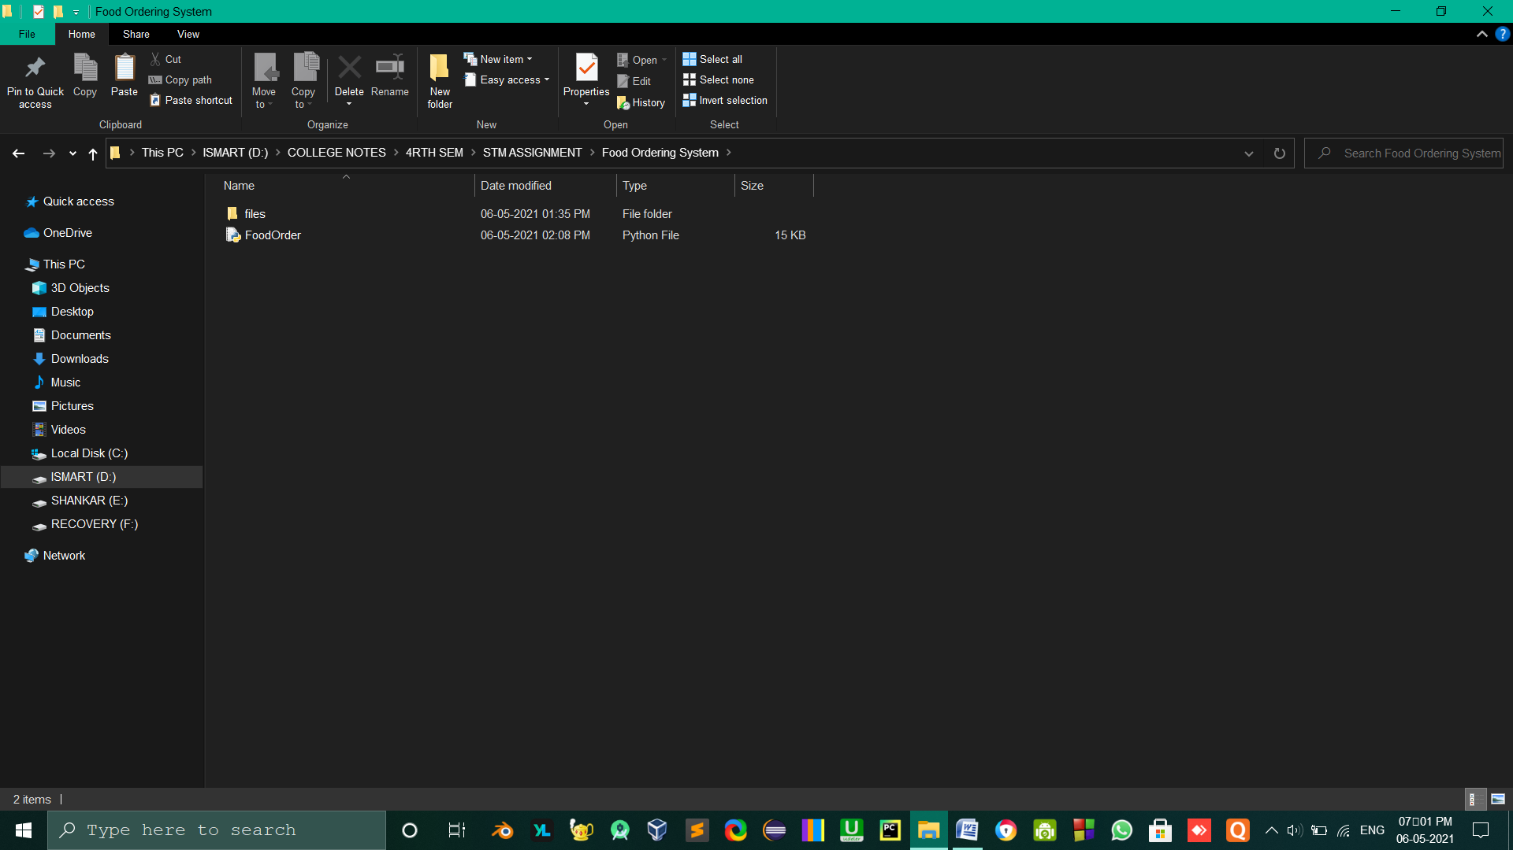

* **This is the path to the files where I have stored on my system**

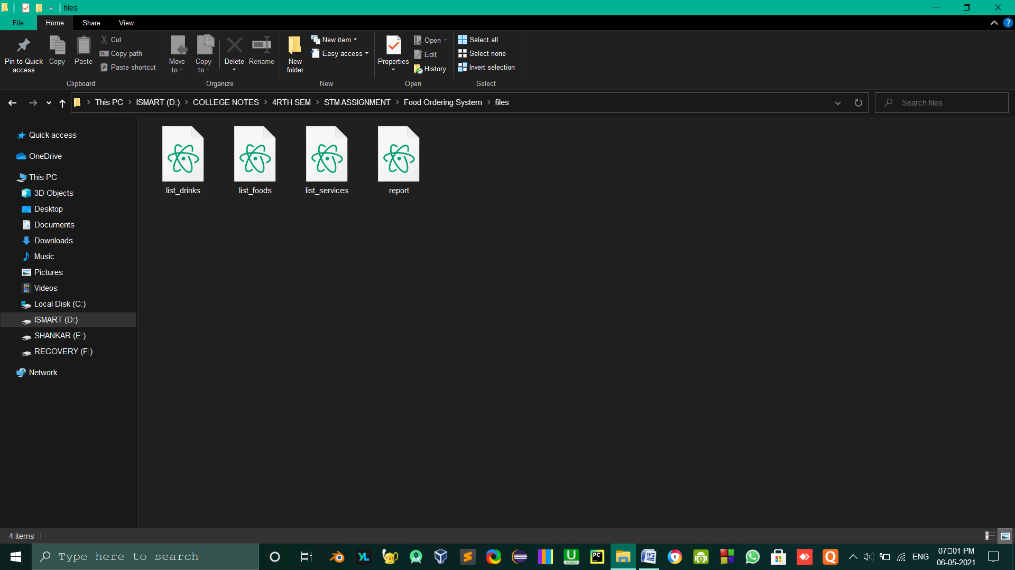

* **These are the list of items**

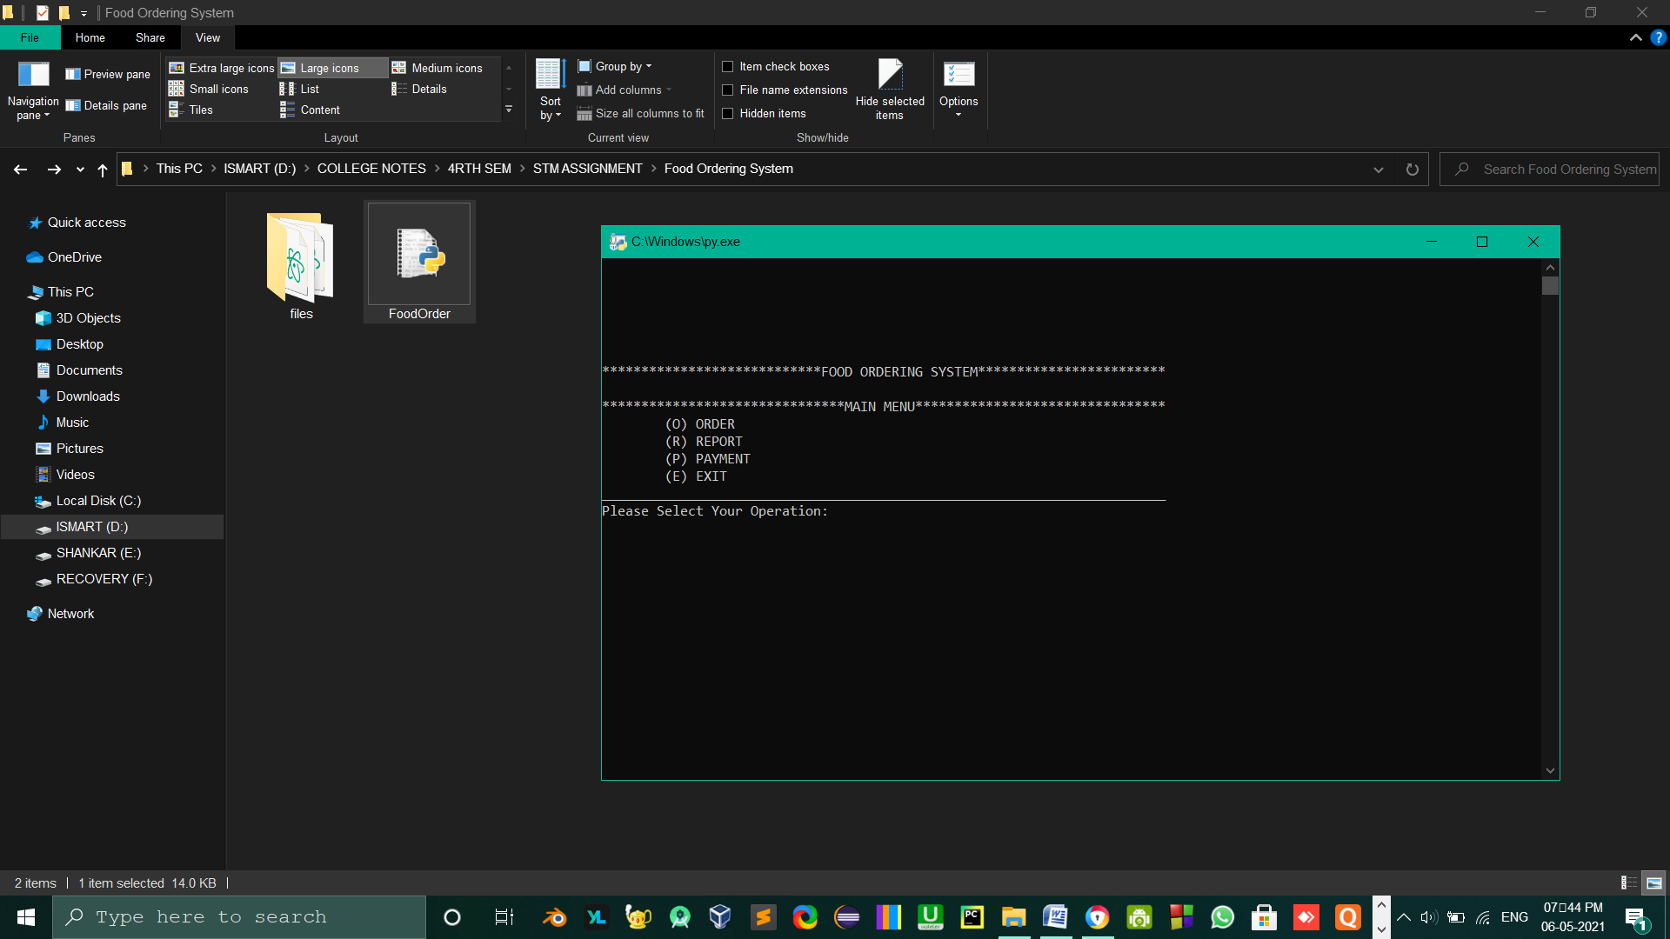

**🡪When double click on the FoodOrder.py file**

**🡪 The program will run and start execution**

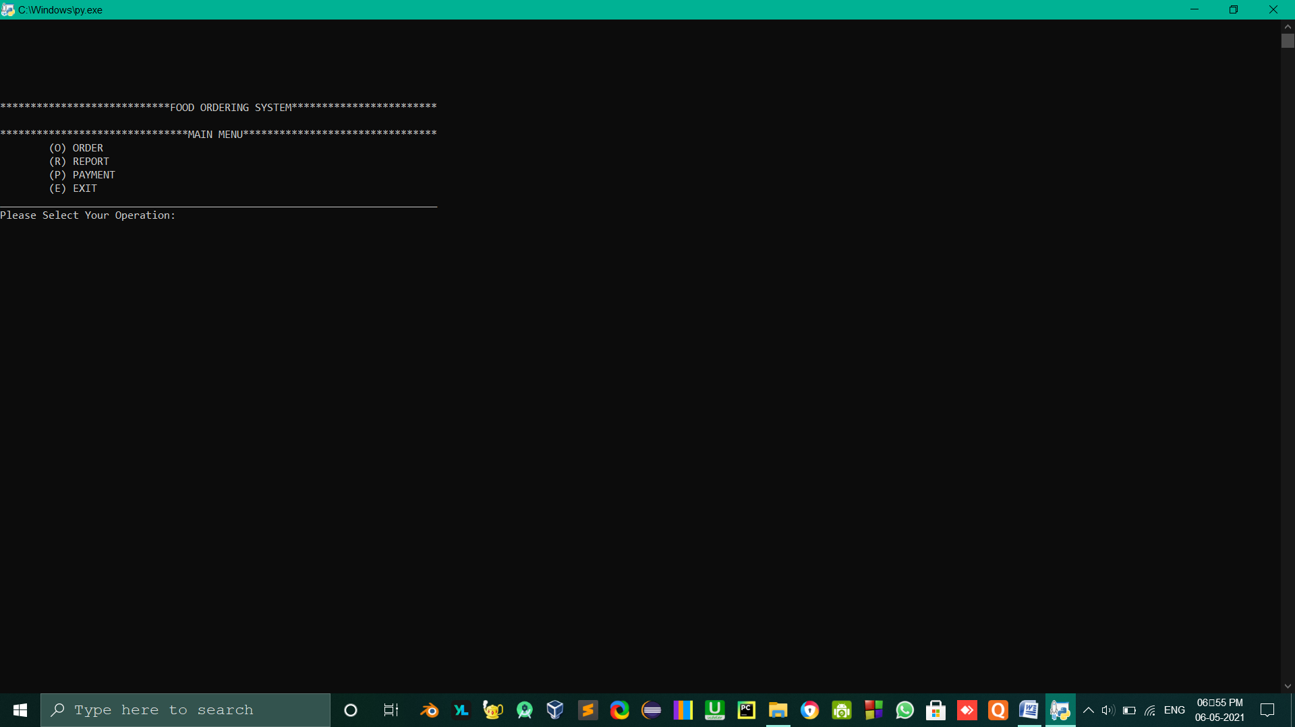

* **Here is the Main menu which we have to choose the operation.**

**\*\*\*\*\*\*\*\*\*\*\*\*\*\*\*\*\*\*\*\*\*\*\*\*\*\*\*\*FOOD ORDERING SYSTEM\*\*\*\*\*\*\*\*\*\*\*\*\*\*\*\*\*\*\*\*\*\*\*\***

**\*\*\*\*\*\*\*\*\*\*\*\*\*\*\*\*\*\*\*\*\*\*\*\*\*\*\*\*\*\*\*MAIN MENU\*\*\*\*\*\*\*\*\*\*\*\*\*\*\*\*\*\*\*\*\*\*\*\*\*\*\*\*\*\*\*\***

**(O) ORDER**

**(R) REPORT**

**(P) PAYMENT**

**(E) EXIT**

**________________________________________________________________________**

**Please Select Your Operation: o**

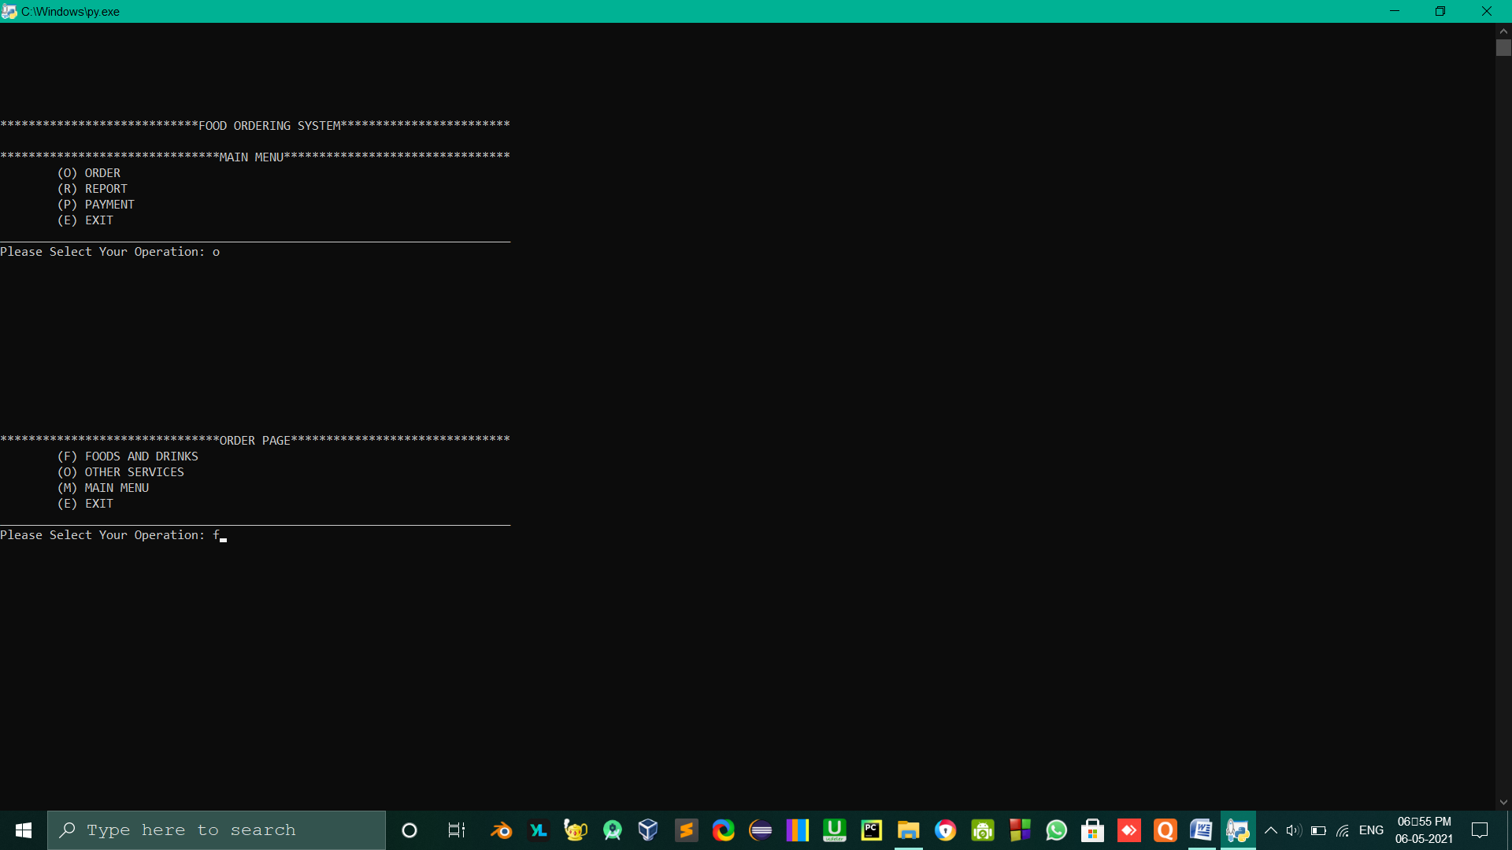

* **Enter ‘O’ for Order**
* **‘R’ for Report**
* **‘P’ for Payment**
* **‘E’ for Exit**

**After that it will display the “Order Page”, Here select which operation you have to perform**

**\*\*\*\*\*\*\*\*\*\*\*\*\*\*\*\*\*\*\*\*\*\*\*\*\*\*\*\*\*\*\*ORDER PAGE\*\*\*\*\*\*\*\*\*\*\*\*\*\*\*\*\*\*\*\*\*\*\*\*\*\*\*\*\*\*\***

**(F) FOODS AND DRINKS**

**(O) OTHER SERVICES**

**(M) MAIN MENU**

**(E) EXIT**

**________________________________________________________________________**

**Please Select Your Operation: f**

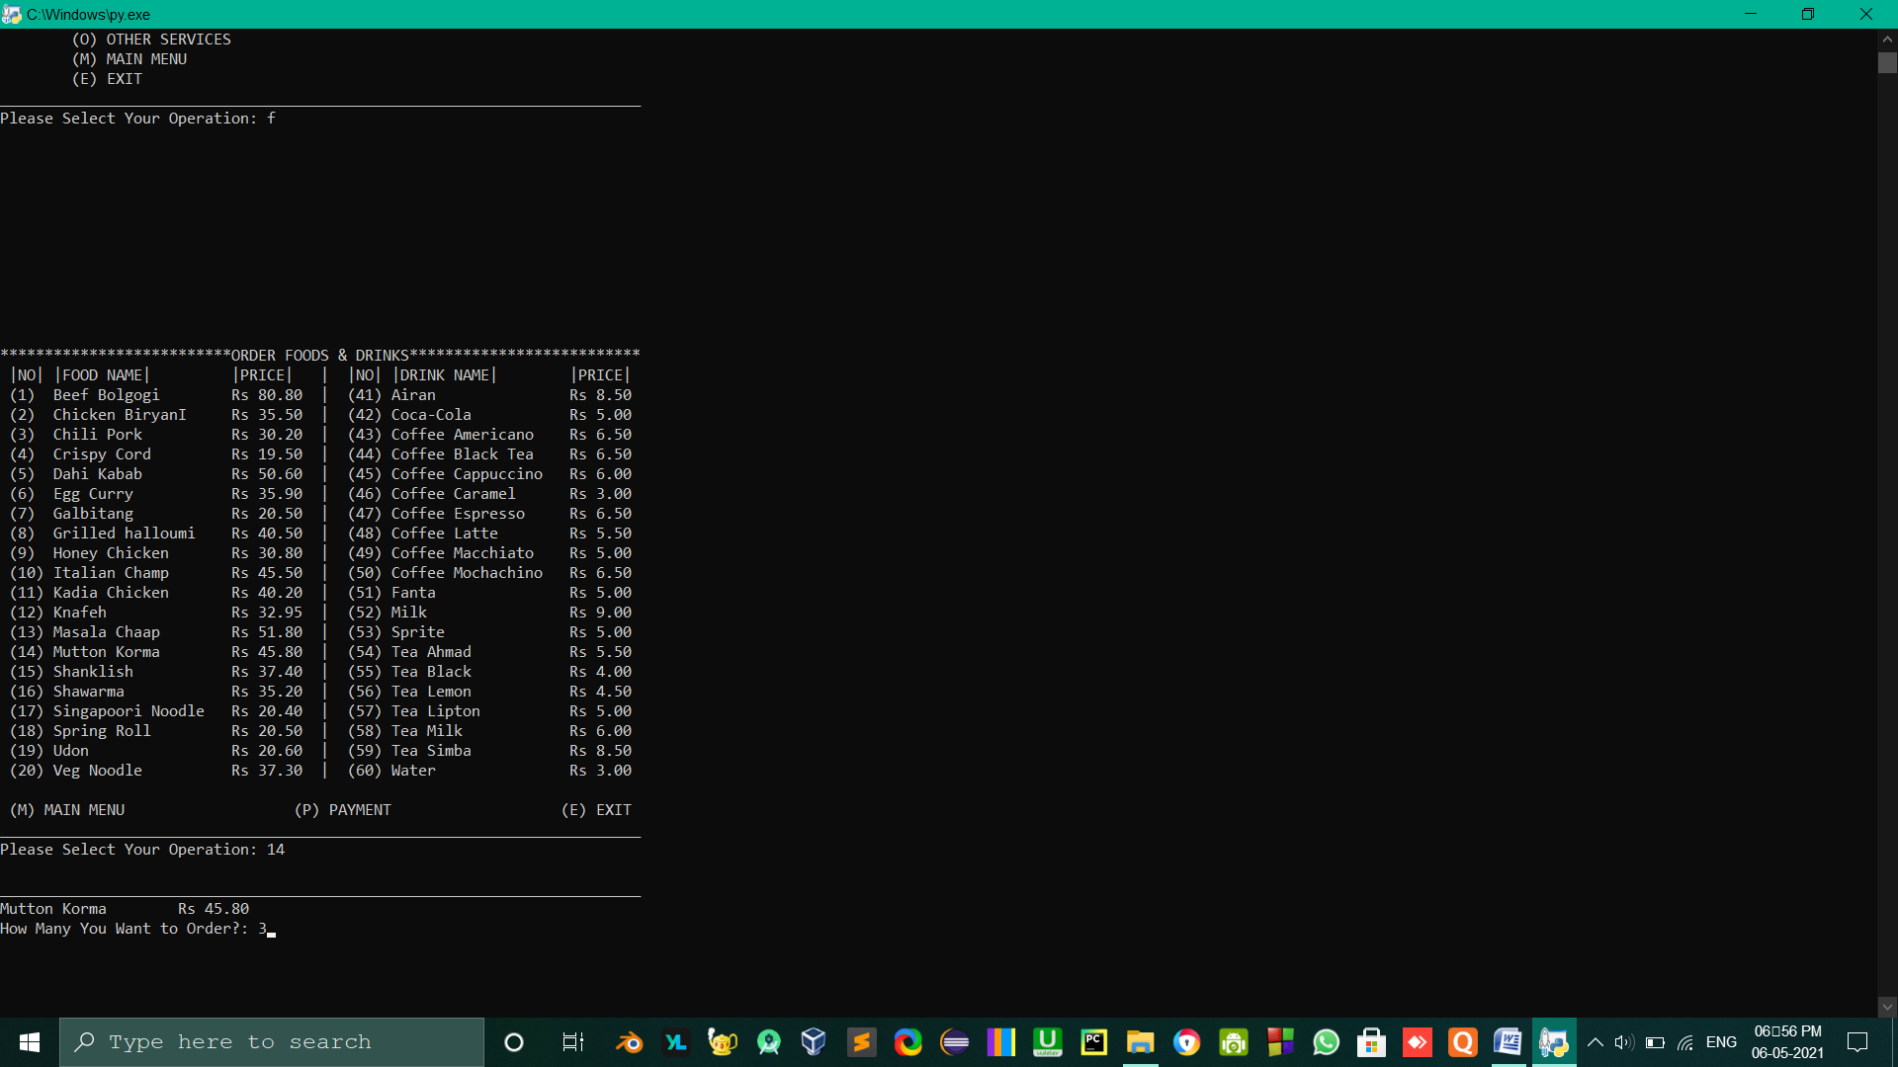

* **Enter your item number : 14[Mutton Korma]**
* **How many you want to Order: 3**

**-------------------------------------------------------------------------------------------------------------------------------**

* **After enter ‘P’ for Payment**

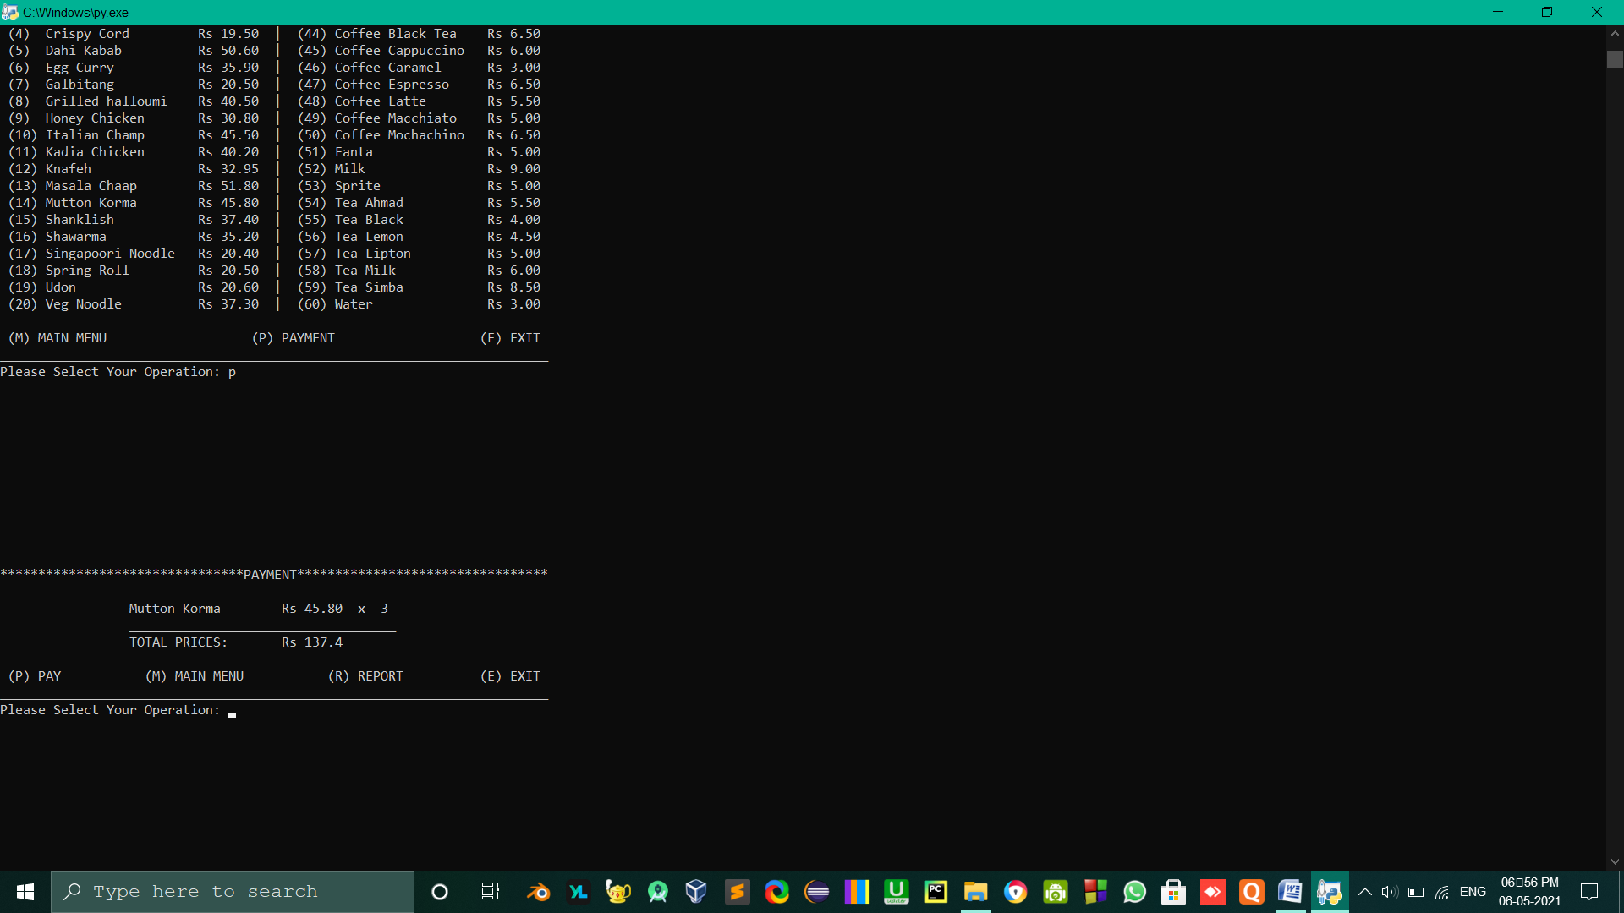

* **Press ‘P’ for pay**

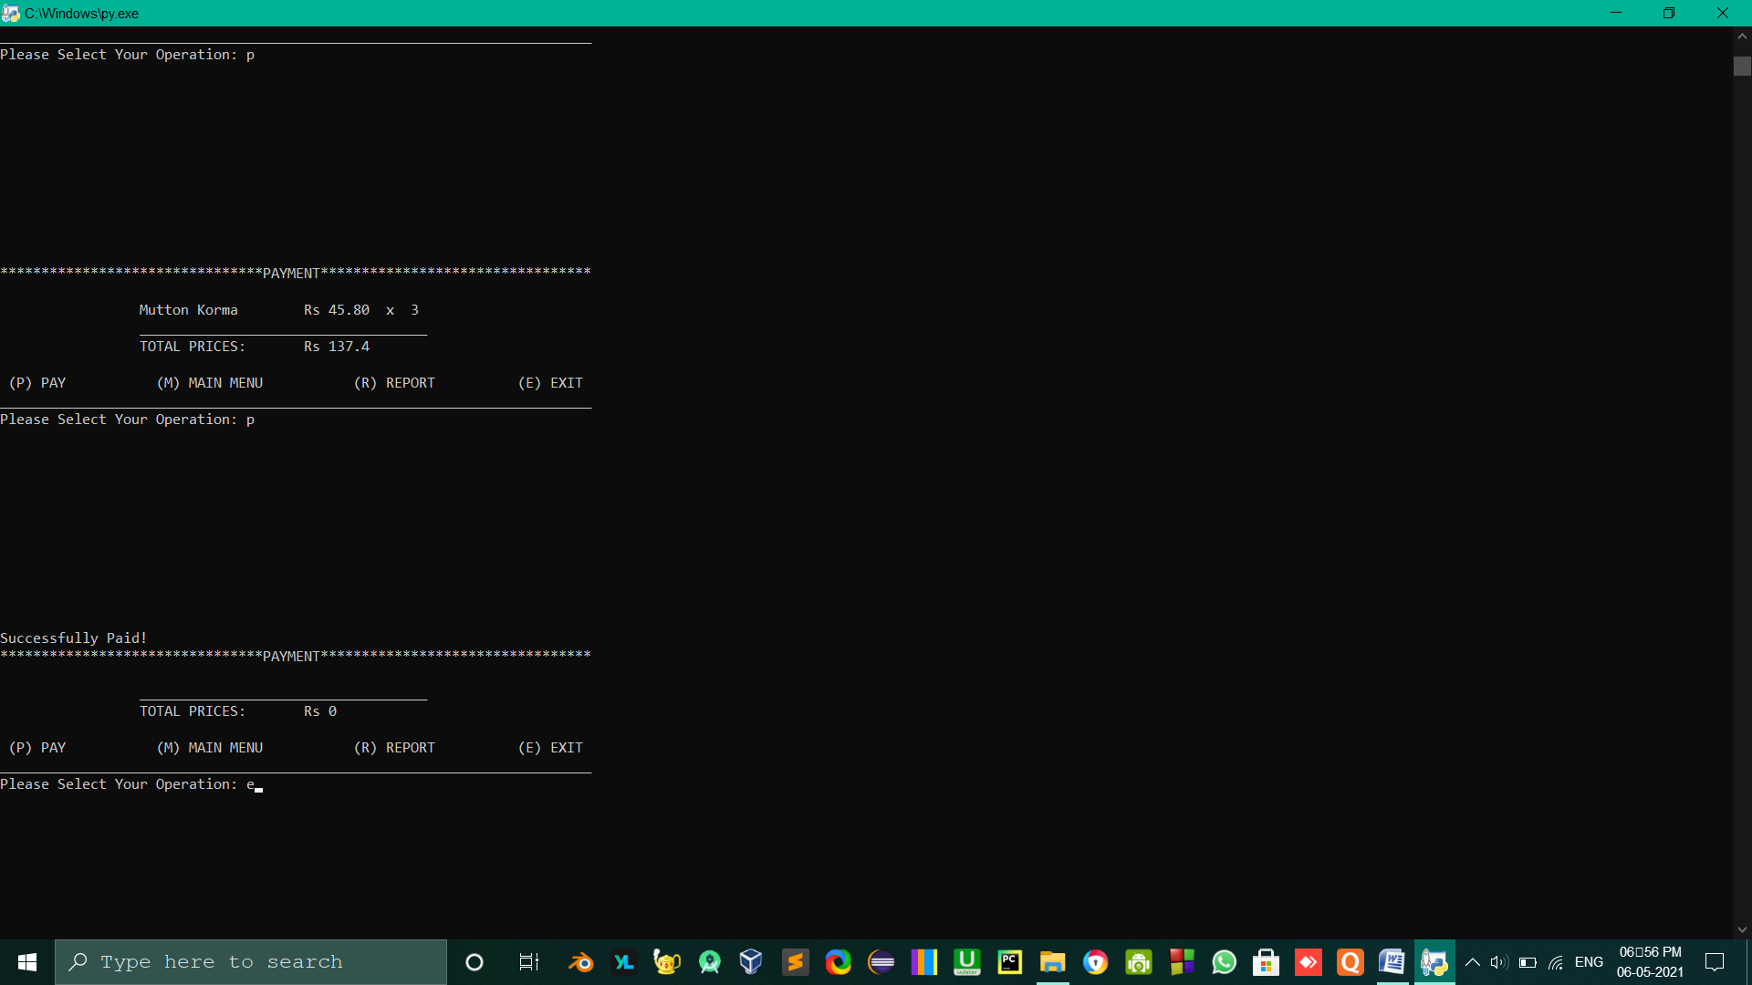

* **Successfully paid!**
* **Press ‘E’ for Exit**

**Control Flow Graph:**